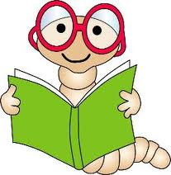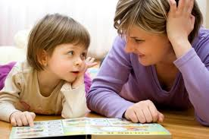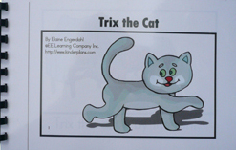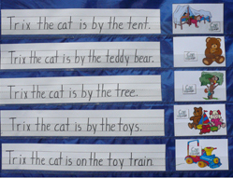

**<http://www.readingrockets.org>**

**By Christian Seda**

**For more strategies and information visit:**

**Tips to follow when reading with an emergent reader:**

**Model finger point-reading. Follow the words with your fingers from left to right as you read them.**

**Encourage reading. Even reading from memory will help provide practice for the student. This will help the child retell a story and navigate correctly**

**Talk about the story with your child or student. Re-read favorite parts and ask the student or child to explain the pictures.**

## **Who are emergent readers?**

Emergent readers are students who:

Know some of the letters of the alphabet

Use “scribble” writing when writing

Understands that writing conveys a message

Recognize letters or words around them in their environment.

## All children can be found somewhere on the path to becoming a reader, even the youngest of children. Teachers and parents can support emergent readers by helping them along their reading path.

**Emergent Readers**

**Strategies to help your child or student become a better reader**

**Echo Reading:**

Echo Reading is where the teacher/parent reads a sentence. After reading the sentence the child will echo what was just read while the teacher or parent points to the words.

**Choral Reading:**

The child will read at the same time as the teacher or parent. Be sure to point to the words so the child can follow along.

**Fill in the Word:**

The teacher/parent will leave out a word or phrase from the story. The child will fill in the missing word or phrase.

**Why Use Shared Reading?**

**Shared reading provides necessary support to struggling readers.**

**Shared reading allows students to enjoy books and materials that they may not be able to read on their own.**

**Shared reading of text that is predictable and repetitive can build sight word knowledge and reading fluency. Shared reading also helps children become more confident and comfortable with reading.**

|  |  |  |  |
| --- | --- | --- | --- |
| **When to use:** | Before reading | During reading | After reading |
| **How to use:** | Individually | With small groups | Whole class setting |

### **Shared Reading Strategies**

Shared reading is a great reading strategy for emergent readers. Shared reading can be done in both a school setting and a home setting. **For Teachers:** Teachers can use this strategy as a whole group activity. The text chosen should be fairly repetitive and predictable; this helps students experience success in reading. The selection of the reading can be displayed on the board, in a pocket chart, a projector, an ELMO, or even on poster board for all the students to see. The teacher will model the reading process and point to the words as he/she reads. This will help students understand how to read from left to right and top to bottom. **For Parents:** Choose a book that is repetitive and predictable. This will help students experience success in reading. When reading to your child point to the words and discusses the pictures shown. This will help the student become familiar with following along and using the pictures to help understand the text.

# **Shared Reading**